 | Course Name: Design Patterns/Thinking LAB | EXPERIMENT NO. 12
 | Course Code: 20CP210P  Faculty: Dr. Payal Chaudhari | Branch: CSE | Semester: IV
(To be filled by Student)
Submitted by: Meet Jain
Roll no: 23BCP093

Objective: To familiarize students with standard Behavioural design patterns.
Experiment: Explain the Memento design pattern and write a program using any object-oriented programming language to demonstrate the working of Memento design pattern.

Code:
package memento;

import java.util.*;

public class Cafe {
public static void main(String[] args) {
CafeOrder order = new CafeOrder();
OrderHistory history = new OrderHistory();

order.addItem("Espresso");
history.save(order.saveState());
System.out.println(order.getOrderDetails());

order.addItem("Croissant");
history.save(order.saveState());
System.out.println(order.getOrderDetails());

order.addItem("Cappuccino");
history.save(order.saveState());
System.out.println(order.getOrderDetails());

order.restoreState(history.undo());
System.out.println("After undo: " + order.getOrderDetails());

order.restoreState(history.undo());
System.out.println("After another undo: " + order.getOrderDetails());
}
}

class CafeOrder {
List<String> items = new ArrayList<>();

public void addItem(String item) {
items.add(item);
}

public String getOrderDetails() {
return "Current Order: " + items;
}

public OrderMemento saveState() {
return new OrderMemento(new ArrayList<>(items));
}

public void restoreState(OrderMemento memento) {
if (memento != null) {
this.items = new ArrayList<>(memento.getItems());
}
}
}

class OrderMemento {
private List<String> items;

public OrderMemento(List<String> items) {
this.items = items;
}

public List<String> getItems() {
return items;
}
}

class OrderHistory {
private List<OrderMemento> history = new ArrayList<>();

public void save(OrderMemento memento) {
if (history.size() == 5) {
history.remove(0);
}
history.add(memento);
}

public OrderMemento undo() {
if (history.size() > 1) {
history.remove(history.size() - 1);
return history.get(history.size() - 1);
}
System.out.println("No more undo available.");
return null;
}
}

Output:
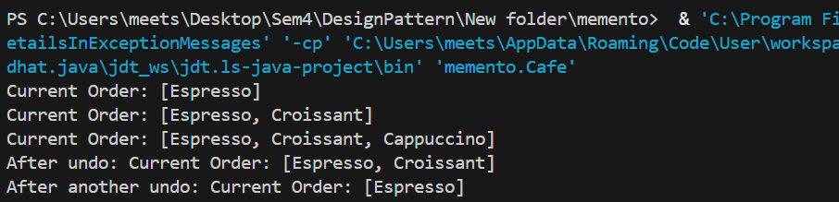

Class Diagram:
